NUTRITION AND ENERGY HEALING
12-17 September 2021

A five-day residential retreat where you’ll establish a bespoke nutrition plan to meet your personal goals, relax with ayurvedic massages and energy healing, accompanied by a healthy, ayurvedic inspired meal plan. And there’s nothing wrong with sampling a glass or two of one of our delicious local organic wines along with your meals whilst you enjoy the very special, bespoke hospitality on offer from your hosts, Mike & Lee.

Photo Credit: TonyMacStudio

WHEN: 12-19 September 2021
PRICE: From €1450 per person

INCLUDES:
- Five nights’ accommodation
- Welcome dinner
- Breakfast & Lunch
- 3 massages, 1 energy healing session, personalised nutrition plan, daily seminar

THE PROGRAMME

12 September. Check in from 15h00. Relax & acclimatise. Welcome dinner 19h30.

13 September. 08h00 Breakfast. 10h00 group introduction & initial nutrition consultations including Dosha planning. 12h30 lunch. 14h00 massages & personal planning.

14 September. 08h00 Breakfast. 09h30 massages, food preparation class, nutrition consultations. 12h30 lunch. 14h00 consultations, massages, energy healing.

15 September. 08h00 Breakfast. 10h00 personalised SMART planning, massages, energy healing. 12h30 lunch. 14h00 Action planning, massages, energy healing.

16 September. 08h00 Breakfast. 09h30 plant-based nutrition. Massages & energy healing. Nutrition consultations. 12h30 lunch. Group discussion. Massages & energy healing. Follow-up nutrition planning.

17 September. 08h00 Breakfast. 10h00 depart Le 1500.

YOUR INSTRUCTORS
CEDRIC CARPANEDO. Cedric joins us from Montpellier where he has his private practice and has for the past five years been an Instructor and Coordinator of the University of Minnesota Program in Montpellier. Cedric’s expertise and experience is unrivalled in his field and he brings with him a holistic approach to healing and stress relief through the use of ayurvedic Abhyanga and Marma stimulation massage.

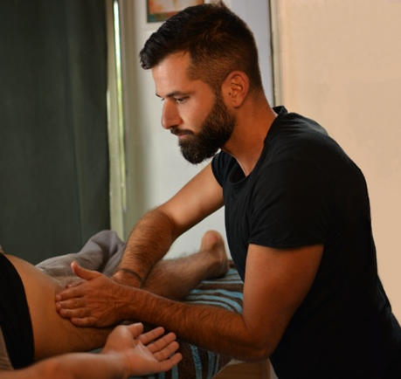

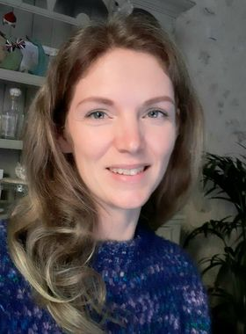
EMMA PENROSE. Emma moved to France in 2011 - a move that changed the way she approached life in many ways. With a healthier, more active lifestyle she noticed how an improved diet affected her health and energy levels dramatically for the better and set herself the goal of educating herself professionally. Emma is now a fully certified nutrition and lifestyle coach who spends much of her time helping others to realise their own health goals.

THE ACCOMMODATION

Le 1500 is a small group of historic buildings dating back to the Twelfth Century, situated in the heart of Saussignac, a hilltop village in the South West of France. The property is a beautiful marriage of contemporary design and medieval history where guests will find a quiet corner to read a book or join the party zone elsewhere.

Our rooms each tell a story and are beautifully appointed, each with ensuite bathroom and plenty of space to relax as well as sleep. The rooms are equipped with a secure safe, bathroom products and pool towels are provided.

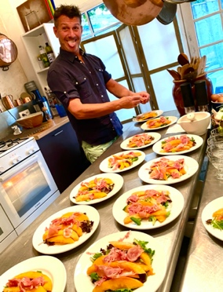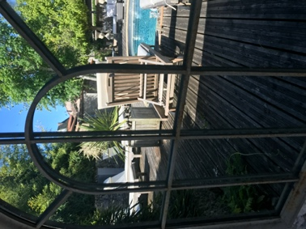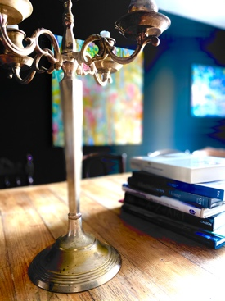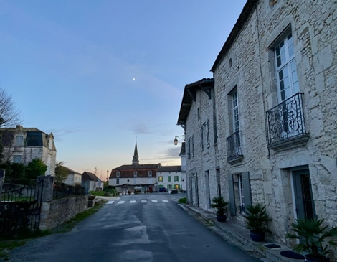
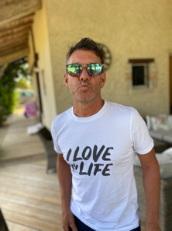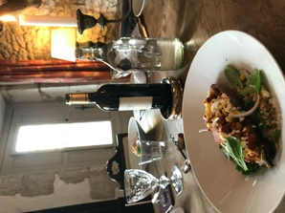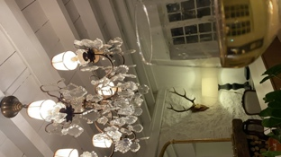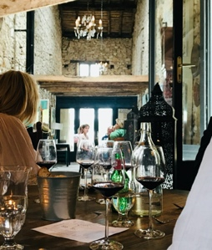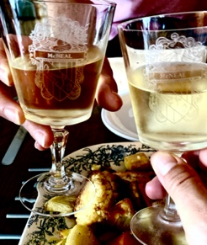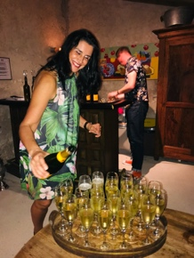

FOODIES LOVE STAYING AT LE 1500

Our reputation for serving beautifully presented, delicious, organic food – all prepared on the premises, on the day – has grown beyond our wildest expectations. Our restaurant is open five days a week to residents and non-residents. As resident guests of Le 1500 you’ll get priority booking and we are happy to cater for private dinners in a location of your choice on the property on the evenings that we are closed. During the Nutrition and Energy Healing Retreat we will be infusing our regular restaurant dishes with a dose of ayurvedic inspiration as well as accents to ensure you are able to follow your personal nutrition goals.

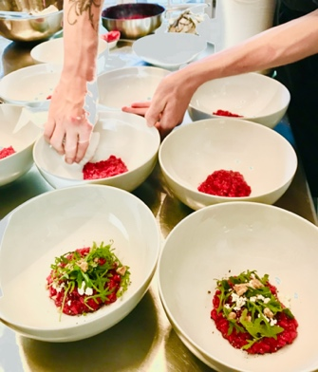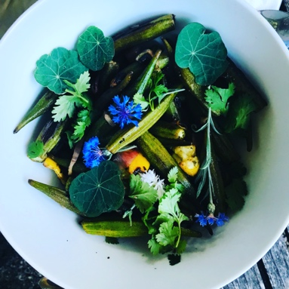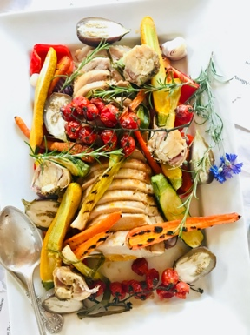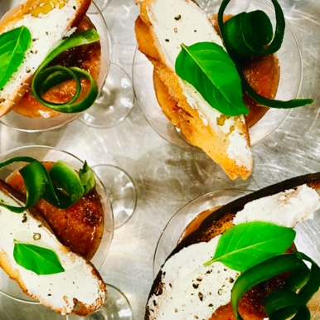
EXPLORE THE REGION

Culturally bursting at the seams with historic cities such as Bordeaux, Bergerac and Sarlat and only 150 minutes from Toulouse, The Nouvelle Aquitaine region boasts some of France’s most incredible sights and experiences. Guests can take a day trip to visit an extraordinary number of stunning places. From the vast beaches and dunes of the West Coast (140 minutes) to the UNESCO world heritage site of the prehistory Vézère Valley and the Lascaux Cave paintings. For the more adventurous, get up early and drive across the border into Spain for lunch in San Sebastian (180 minutes). Or stay closer to home and visit one of the area’s stunning authentic French markets, visit the world-famous Dordogne Valley with its 1001 Chateaux or just step outside Le 1500 and walk through the thousands of hectares of vineyards on our doorstep.

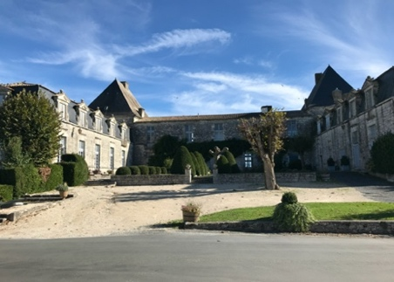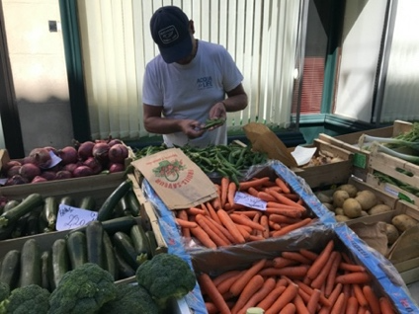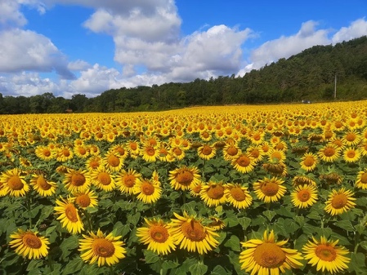

FLIGHTS

There’s no shortage of flight options to transport you to Le 1500. Our nearest airport, Bergerac is a 20 minute car ride and is regularly served by British Airways (London City and Southampton) and RyanAir (London, Liverpool, Bristol and Bournemouth) in the UK. Flights also operate from Belgium and The Netherlands. Bordeaux Airport is a 90 minute car ride (train transport to Gardonne, five minutes from Saussignac, is also possible) away and is served by a variety of international airlines from around the world, as well as internal flights from across France.

We’re happy to organise a chauffeur to pick you up from one of the airports or the train station.

CAR HIRE

Car hire is available directly from Bergerac and Bordeaux airports. Alternatively, we’re happy to get you to a car hire location in Bergerac once you’ve settled in at Le 1500. Advance booking is advised especially during peak season. Having a car at your disposal will allow you greater opportunities to explore the region independently.
RESERVE YOUR PLACE NOW
CONTACT LEE OR MIKE AT saussignac@yahoo.com OR BY CALLING +33 6 42 13 93 67

LE 1500
WHERE TIME BEHAVES

WWW.LE1500.ROCKS

