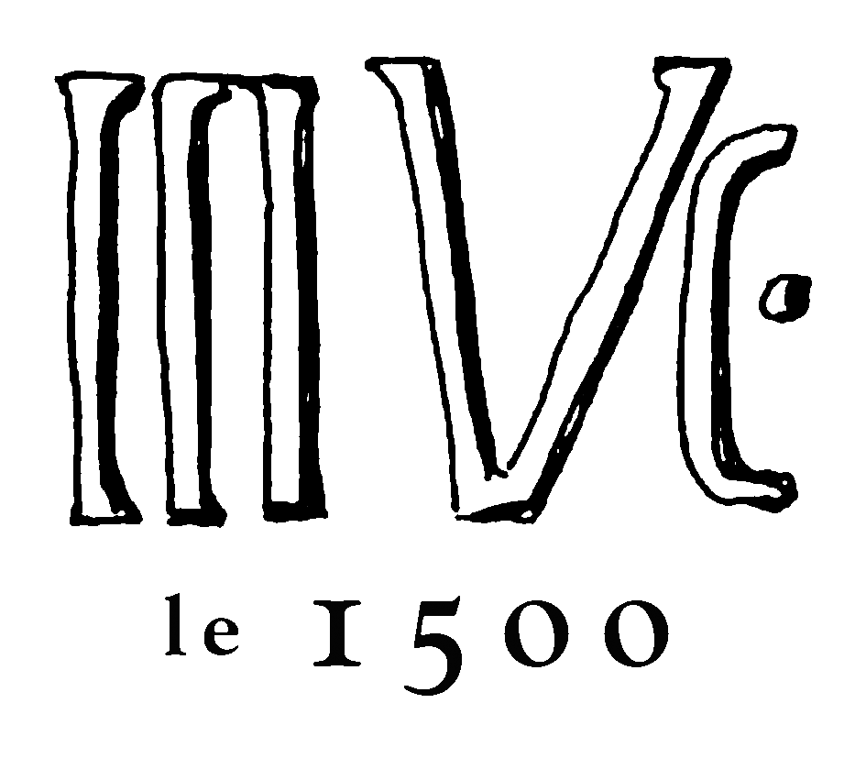
LOGEMENT | ART | RESTAURATION | DÉTENTE

LUNCHEON - 4TH JANAURY 2017

Home Made Chicken Liver Paté, Toast and Charcuterie
or
Spicy Cabbage Salad with Pumpkin Seeds and Chilli Lime Dressing

Beef Carbonnade served with Roast Carrots, Peas and Garlic Mashed Potatoes
or
Slow Roast Chicken with Garlic, Rosemary and Lemon, Braised Red Cabbage and Celeriac

Sticky Toffee Pudding
or
Lemon Cheesecake

20€ per head | a choice of three courses from the above | two glasses of house wine or beer | coffee

05 53 23 85 15 / saussignac@yahoo.com

